The following article describes how a random forest is constructed and how it works.

Table of contents:
1. Basics
2. Building of a Random Forest
3. Usage of a Random Forest
4. Evaluation of a Random Forest
5. Code Example

1. Basics

Random Forest is a supervized machine learning algorithm and is an ensemble of Decision Trees, most of the time trained with the “bagging” method. The general idea of bagging method is that a combination of learning models increases the overall result. In easy words: Random forest builds multiple decision trees and merges them together to get a more accurate and stable prediction.
Random Forest combine the simplicity of decision trees with flexibility resulting in a vast improvement in accuracy.

2. Building a Random Forest

First we have to split the datasat in training- and test data. The realtion therefore should be 75-25%. The 75% trainings data is now considered to be the “bootstrapped dataset”.
Second we have to create a Decsion Tree from the bootstrapped dataset according to previous article “Decision Trees”, but only using a random subset of features at each step. In this example we are going to randomly select 2 out of 4 features. Using the same data set from article “Decision Trees”, “Good Blood Circ.” and “Blocked Arteries” were selected.

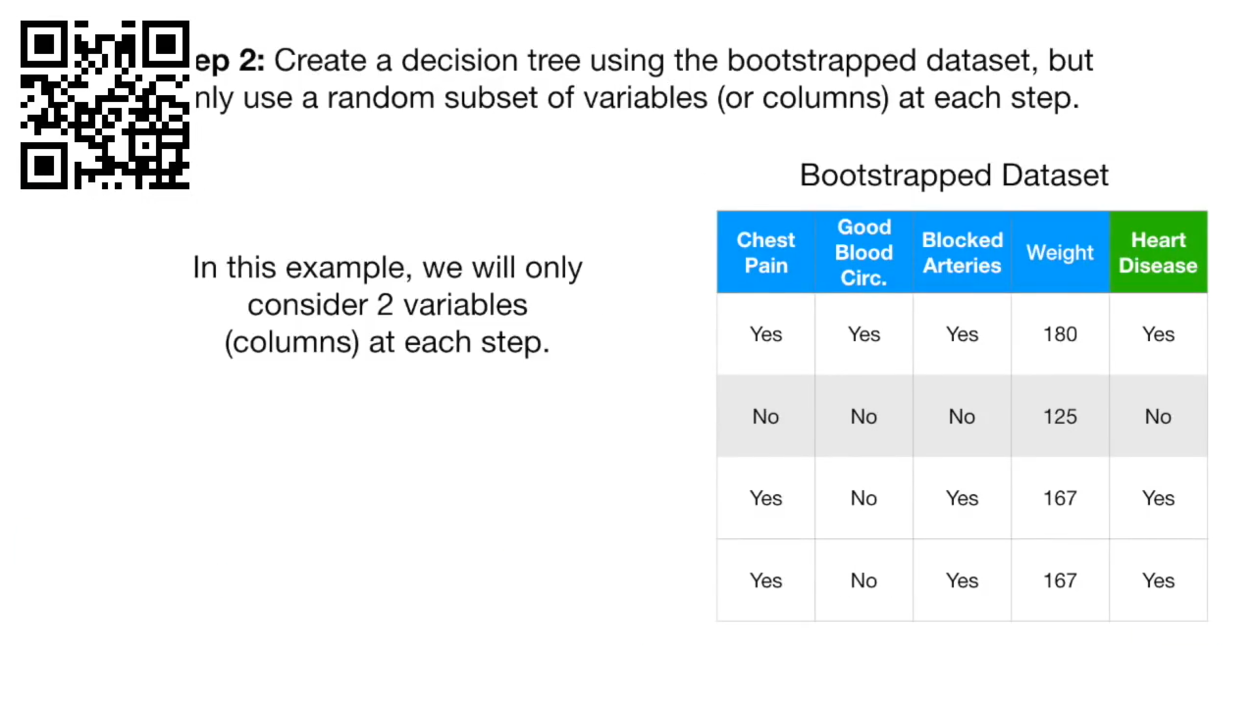

For building a Decision Tree the root node needs to be determined by these 2 features. For both features the Gini-Index needs to be calculated. Since this was already explained in article “Decision Trees”, this will be skipped here.
Now we assume, Good Blood Circulation has the lowest Gini-Index. Thus, it will be the root node of this decision tree. For all created decision nodes we again randomly select 2 variables that further separates the data set. This is done until the decision tree is fully created with leaf nodes. Now we have one Decision Tree. To build a Random Forest we needs to establish a ensemble of different Decision Trees.
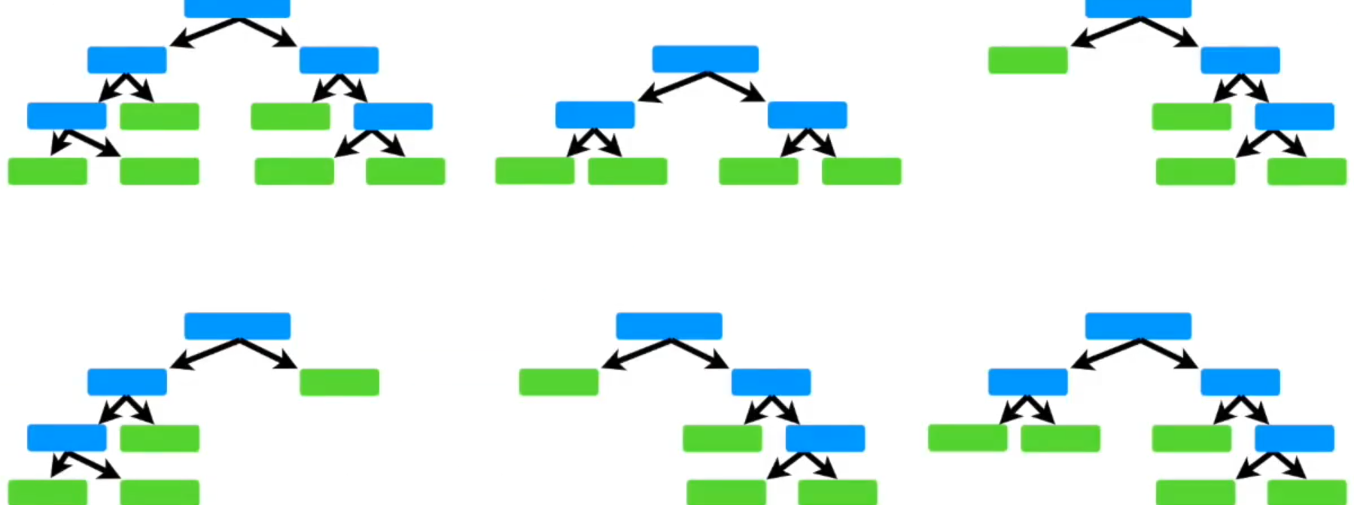
So we have to repeat the generation of a new bootstrapped data with all its following steps. Finally we have a collection of e.g. 6 different decision trees.

3. Usage of a Random Forest
To figure out how a Random Forest works, we need to create a new sample (patient) from the 25% of the test data. The result of the Decision Tree should be to say, weather this new patient has heart disease or not.
We take this patient and let it run down the first Decision Tree:
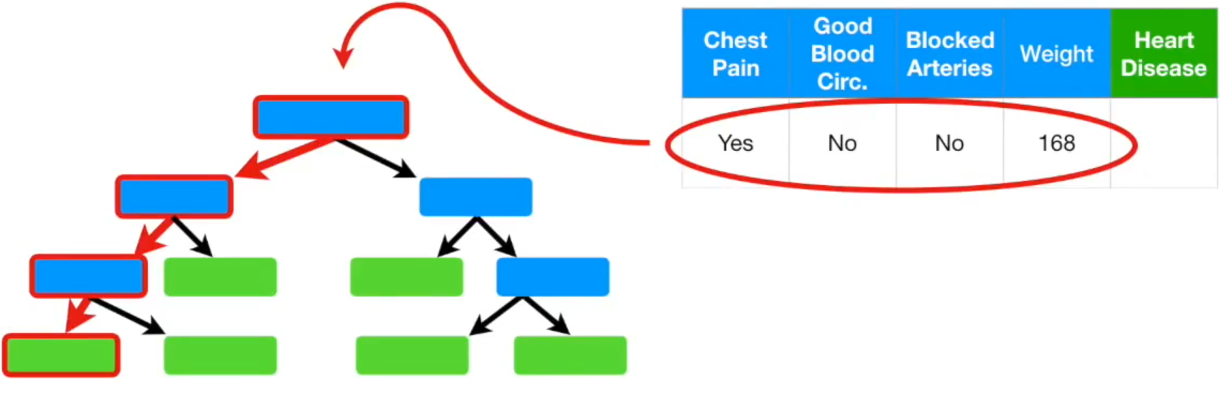
The first tree predicted “yes”, the new patient has heart disease.
(“yes”: 1, “no”: 0)
Now this patient run down the second Decision Tree we set up. This tree also says “yes”, the new patient has heart disease.
(“yes”: 2, “no”: 0)

This has to be done for all the remaining Decision Trees. Finally we see, which option received more votes:
(“yes”: 5, “no”: 1)

4. Evaluation of a Random Forest

For this patient “yes” received the most votes. Thus it can be concluded that the prediction of this patient is heart disease.
Now we compare the prediction of the Random Forest of the new patient with its actual label. The actual label of this patient is “yes”. Thus, the prediction of the Random Forest is correct. According to this, we repeat this for all the remaining patients within the test data.
To get the final accuracy of the Random Forest, we take the proportion of correct labels in relation of all patient of the test data.

To might get a better accuracy, we start again from 2. Building a Random Forest by considering 3 (4) instead of only 2 randomly selected features. We then compare the result of all Random Forest and select that one, that makes the best predictions.

5. Code Example

# creates a random forest with a maximum node-depth of 4
# and a minumum number of 3 examples per leaf

MODEL = RandomForestClassifier(criterion="gini", max_depth=4, min_samples_leaf=3)

